A

A

C

A

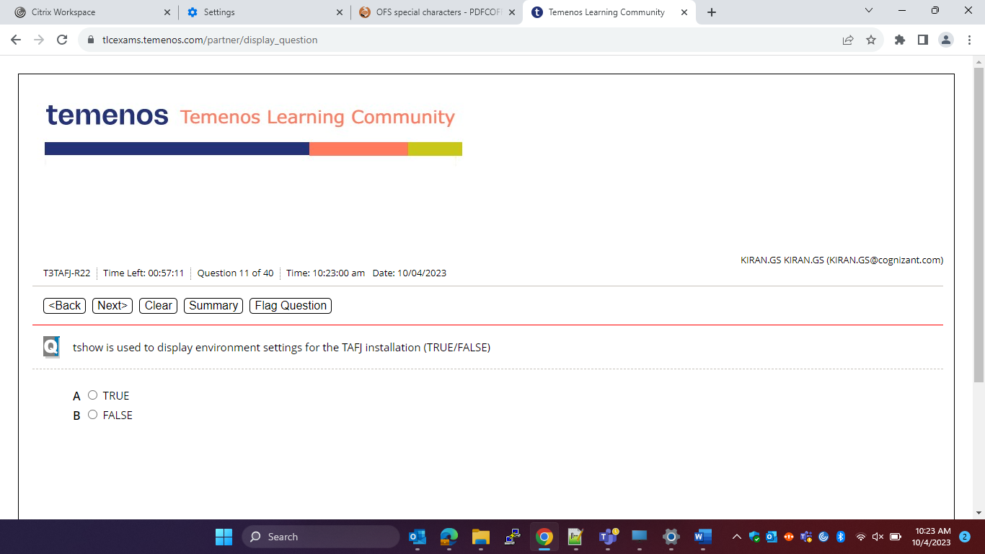

B

B

A

C

B

A

B

D

D

E

A

B

A

A

D

C

D

C

C

A

C

B

A

E

A

C

D